Problem with git

Go to explorer

Then go to your windows user path

C:\Users\B03831A

If ssh folder is not there then go to git bash and run

Ssh-keygen -t rsa

Enter

Enter

Enter

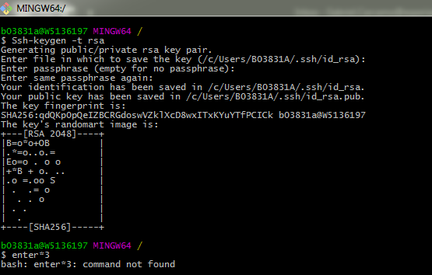

Go to folder C:\Users\B03831A

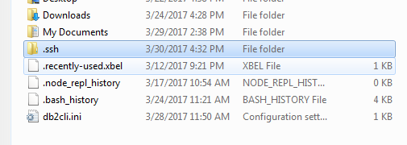

Open file id_rsa.pub



Copy key and go to bitbucket -> manage account



Then go to ssh key -> add key

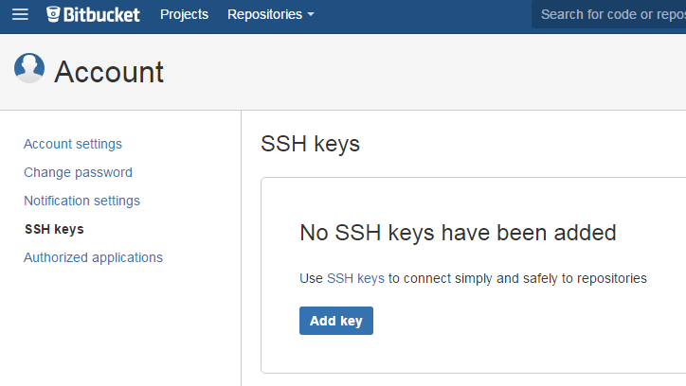

Copy paste your key -> then add key botton

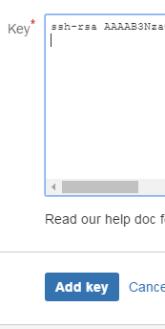

Then go to git bash and try to perform a git clone of anything

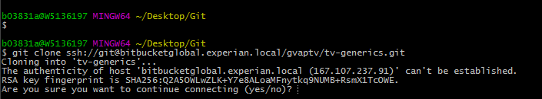

Put yes , you should see the following:

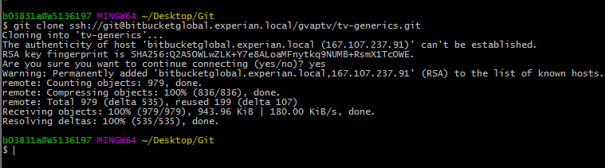

If you receive a message like the following:

rted by user [Gabriel Carcamo](http://localhost:8080/user/b03831a)

Building in workspace C:\Program Files (x86)\Jenkins\workspace\Test_GC_1

> C:\Program Files\Git\bin\git.exe rev-parse --is-inside-work-tree # timeout=10

Fetching changes from the remote Git repository

> C:\Program Files\Git\bin\git.exe config remote.origin.url <http://B03831A@bitbucketglobal.experian.local/scm/gvaptv/trended-report---dft.git> # timeout=10

Fetching upstream changes from <http://B03831A@bitbucketglobal.experian.local/scm/gvaptv/trended-report---dft.git>

> C:\Program Files\Git\bin\git.exe --version # timeout=10

using GIT_ASKPASS to set credentials

> C:\Program Files\Git\bin\git.exe fetch --tags --progress <http://B03831A@bitbucketglobal.experian.local/scm/gvaptv/trended-report---dft.git> +refs/heads/*:refs/remotes/origin/* # timeout=1

ERROR: Timeout after 1 minutes

[ERROR](http://stacktrace.jenkins-ci.org/search?query=ERROR): Error fetching remote repo 'origin'

[hudson.plugins.git.GitException](http://stacktrace.jenkins-ci.org/search?query=hudson.plugins.git.GitException): Failed to fetch from <http://B03831A@bitbucketglobal.experian.local/scm/gvaptv/trended-report---dft.git>

at [hudson.plugins.git.GitSCM.fetchFrom(GitSCM.java:806)](http://stacktrace.jenkins-ci.org/search/?query=hudson.plugins.git.GitSCM.fetchFrom&entity=method)

at [hudson.plugins.git.GitSCM.retrieveChanges(GitSCM.java:1070)](http://stacktrace.jenkins-ci.org/search/?query=hudson.plugins.git.GitSCM.retrieveChanges&entity=method)

at [hudson.plugins.git.GitSCM.checkout(GitSCM.java:1101)](http://stacktrace.jenkins-ci.org/search/?query=hudson.plugins.git.GitSCM.checkout&entity=method)

at [hudson.scm.SCM.checkout(SCM.java:496)](http://stacktrace.jenkins-ci.org/search/?query=hudson.scm.SCM.checkout&entity=method)

at [hudson.model.AbstractProject.checkout(AbstractProject.java:1278)](http://stacktrace.jenkins-ci.org/search/?query=hudson.model.AbstractProject.checkout&entity=method)

at [hudson.model.AbstractBuild$AbstractBuildExecution.defaultCheckout(AbstractBuild.java:604)](http://stacktrace.jenkins-ci.org/search/?query=hudson.model.AbstractBuild$AbstractBuildExecution.defaultCheckout&entity=method)

at [jenkins.scm.SCMCheckoutStrategy.checkout(SCMCheckoutStrategy.java:86)](http://stacktrace.jenkins-ci.org/search/?query=jenkins.scm.SCMCheckoutStrategy.checkout&entity=method)

at [hudson.model.AbstractBuild$AbstractBuildExecution.run(AbstractBuild.java:529)](http://stacktrace.jenkins-ci.org/search/?query=hudson.model.AbstractBuild$AbstractBuildExecution.run&entity=method)

at [hudson.model.Run.execute(Run.java:1728)](http://stacktrace.jenkins-ci.org/search/?query=hudson.model.Run.execute&entity=method)

at [hudson.model.FreeStyleBuild.run(FreeStyleBuild.java:43)](http://stacktrace.jenkins-ci.org/search/?query=hudson.model.FreeStyleBuild.run&entity=method)

at [hudson.model.ResourceController.execute(ResourceController.java:98)](http://stacktrace.jenkins-ci.org/search/?query=hudson.model.ResourceController.execute&entity=method)

at [hudson.model.Executor.run(Executor.java:405)](http://stacktrace.jenkins-ci.org/search/?query=hudson.model.Executor.run&entity=method)

Caused by: [hudson.plugins.git.GitException](http://stacktrace.jenkins-ci.org/search?query=hudson.plugins.git.GitException): Command "C:\Program Files\Git\bin\git.exe fetch --tags --progress <http://B03831A@bitbucketglobal.experian.local/scm/gvaptv/trended-report---dft.git> +refs/heads/*:refs/remotes/origin/*" returned status code -1:

stdout:

stderr:

at org.jenkinsci.plugins.gitclient.CliGitAPIImpl.launchCommandIn(CliGitAPIImpl.java:1799)

at org.jenkinsci.plugins.gitclient.CliGitAPIImpl.launchCommandWithCredentials(CliGitAPIImpl.java:1525)

at org.jenkinsci.plugins.gitclient.CliGitAPIImpl.access$300(CliGitAPIImpl.java:65)

at org.jenkinsci.plugins.gitclient.CliGitAPIImpl$1.execute(CliGitAPIImpl.java:316)

at hudson.plugins.git.GitSCM.fetchFrom(GitSCM.java:804)

... 11 more

ERROR: null

[Finished](http://stacktrace.jenkins-ci.org/search?query=Finished): FAILURE

Then uninstall Git and reinstall from this version.

